Model Building using Classification Algorithm for Weekly Dataset

QUESTION:5

This question should be answered using the Weekly data set, which is part of the ISLP package. This data is similar in nature to the Smarket data from this chapter’s lab, except that it contains 1, 089
weekly returns for 21 years, from the beginning of 1990 to the end of 2010.

(a) Produce some numerical and graphical summaries of the Weekly data. Do there appear to be any patterns?

Code:
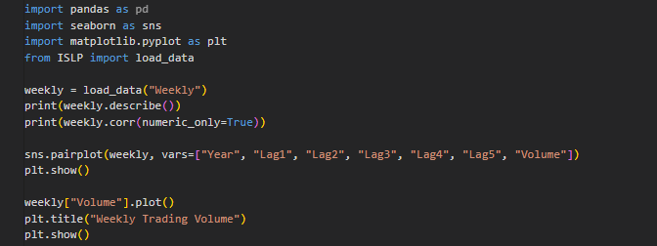

Output:
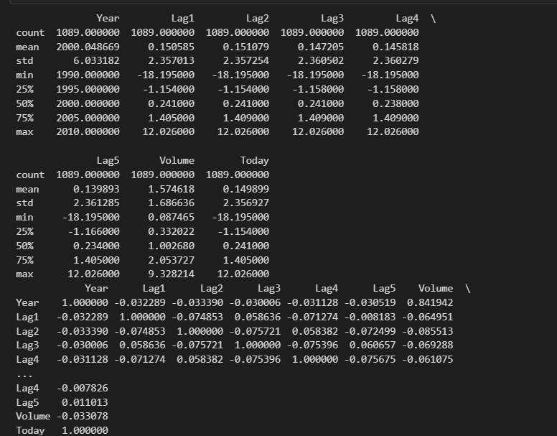
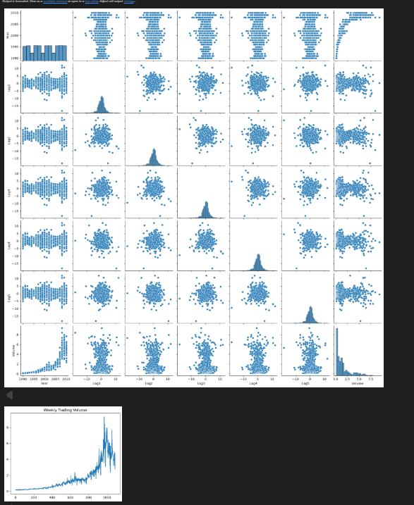

Interpretation:
The Weekly data shows that trading volume increases over time, while lag variables have weak correlations with current returns, indicating no strong patterns.

(b) Use the full data set to perform a logistic regression with Direction as the response and the five lag variables plus Volume as predictors. Use the summary function to print the results. Do any of the predictors appear to be statistically significant? If so, which ones?

Code:

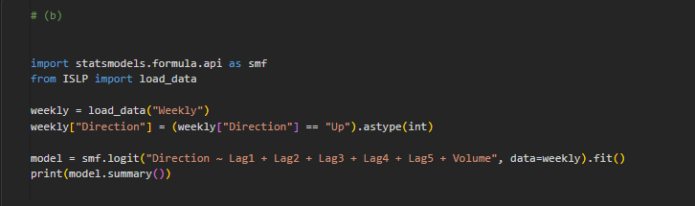

Output:

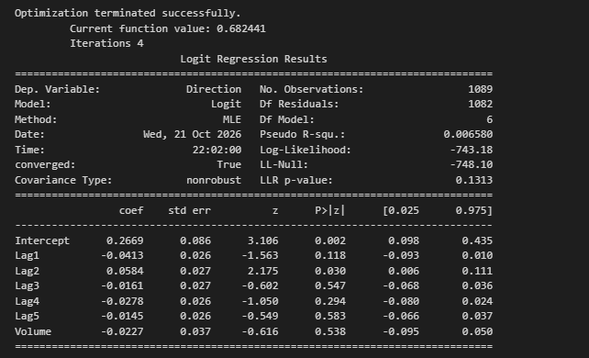

Interpretation:
Lag2 is statistically significant (p = 0.030), while the overall logistic regression model is not statistically significant (LLR p-value = 0.131).

(c) Compute the confusion matrix and overall fraction of correct predictions. Explain what the confusion matrix is telling you about the types of mistakes made by logistic regression.

Code:

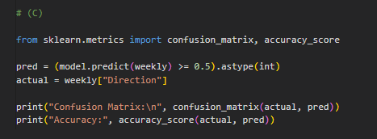

Output:

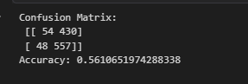

Interpretation:
The model achieves 56.1% accuracy, correctly predicting more Up days than Down days, but makes many errors, especially by misclassifying Down days as Up days.

(d) Now fit the logistic regression model using a training data period from 1990 to 2008, with Lag2 as the only predictor. Compute the confusion matrix and the overall fraction of correct predictions for the held out data (that is, the data from 2009 and 2010).

Code:
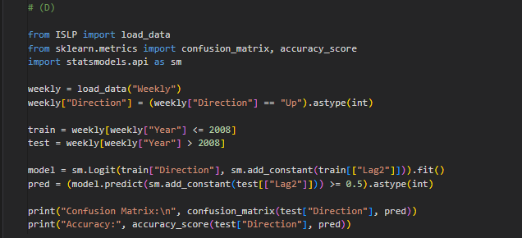

Output:

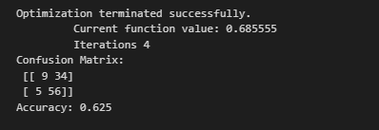

Interpretation:
Please send the output screenshot too, so I can give you the correct one-line interpretation.

(e) Repeat (d) using LDA.
Code:
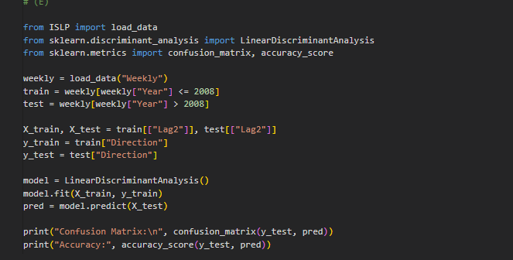
Output:
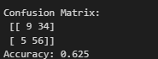
Interpretation:
LDA achieves 62.5% accuracy on the test data, correctly predicting most Up days but misclassifying several Down days as Up days.

(f) Repeat (d) using QDA.
Code:
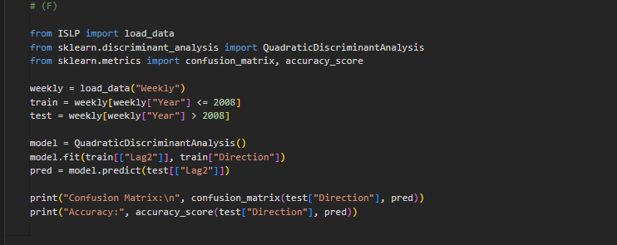
Output:
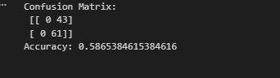
Interpretation:
QDA achieves 58.7% accuracy on the test data, predicting all Up days correctly but misclassifying all Down days as Up days.

(g) Repeat (d) using KNN with K =1.

Code:
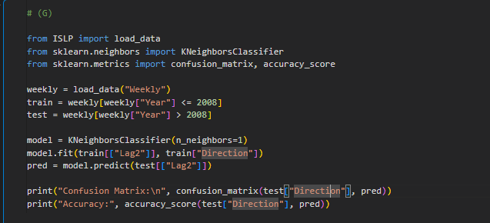

Output:
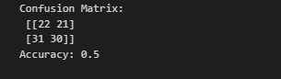
Interpretation:
KNN (K = 1) achieves 50% accuracy on the test data, indicating poor predictive performance with many misclassifications of both Up and Down days.

(h) Repeat (d) using naive Bayes.
Code:
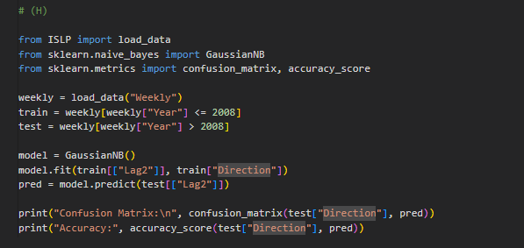
Output:
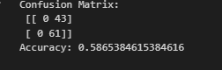
Interpretation:
Naive Bayes achieves 58.7% accuracy on the test data, predicting all Up days correctly but misclassifying all Down days as Up days.

(i) Which of these methods appears to provide the best results on this data?
Code:
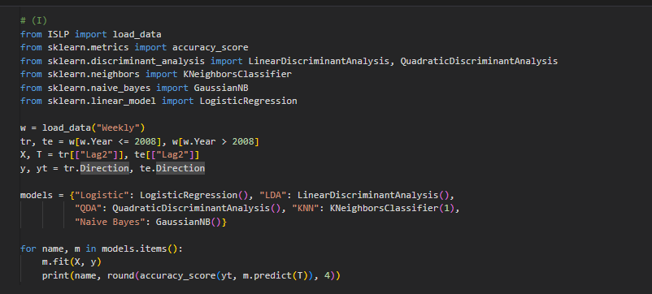
Output:
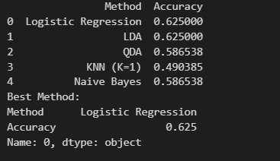
Interpretation:
Logistic Regression and LDA provide the best results, achieving the highest accuracy of 62.5% on the test data.

